Tax Provisions in House stimulus bill (Families First Coronavirus Response Act) – updated 3/16/20 5:30pm:

- Emergency Family and Medical Leave Act – up to 12 weeks’ job protection, first 2 weeks can be unpaid or allow them to use vacation. After that must pay at a rate of 2/3 usual pay. Uncertainty how broad this will be to cover self-quarantine – see excerpt below.
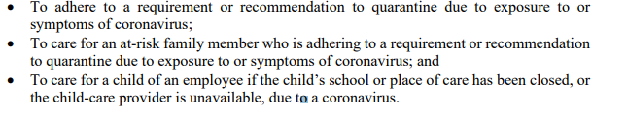
HOW WILL THIS AFFECT EMPLOYER? Tax Credit against employer payroll tax, refundable. $200 per day per individual up to $10k total. Credit claimed quarterly.

- Emergency Paid Sick Leave:
  - Two Weeks of sick leave (usual pay) for more serious COVID-19 issues i.e. symptoms, at-risk quarantine or 2/3 for usual pay if leave to care for family member for such purposes.
HOW WILL THIS AFFECT EMPLOYER? Tax Credit against employer payroll tax, refundable. $200 per day to care for children whose school has been cancelled. $511 for those who must self-isolate, obtain a diagnosis, or comply with self-isolation rules. Credit claimed quarterly.

- Enhanced Unemployment Benefits –
  - Grants for states with large spikes in unemployment
  - Provides flexibility in Unemployment restrictions and eligibility.

NOTES:
- Pending approval of Senate, they appear to be concerned it isn’t enough and won’t be administered quick enough.
- Appears to be uncertainty in what is a “recommendation to quarantine.” Are they prepared to reimburse business owners for paying their people to stay home.

